KB64 -

Functionality
Incorrect reposting was done using transaction code KB61. This reposting can be reversed using this transaction.

Scenario
Incorrect reposting was done using transaction code KB61. This reposting can be reversed using this transaction.

Requirements
Incorrect reposting done using transaction code KB61.

Menu Path | Accounting → Controlling → Cost Center Accounting → Actual Postings → Repost Line Items → KB64 - Reverse
Transaction Code | KB64

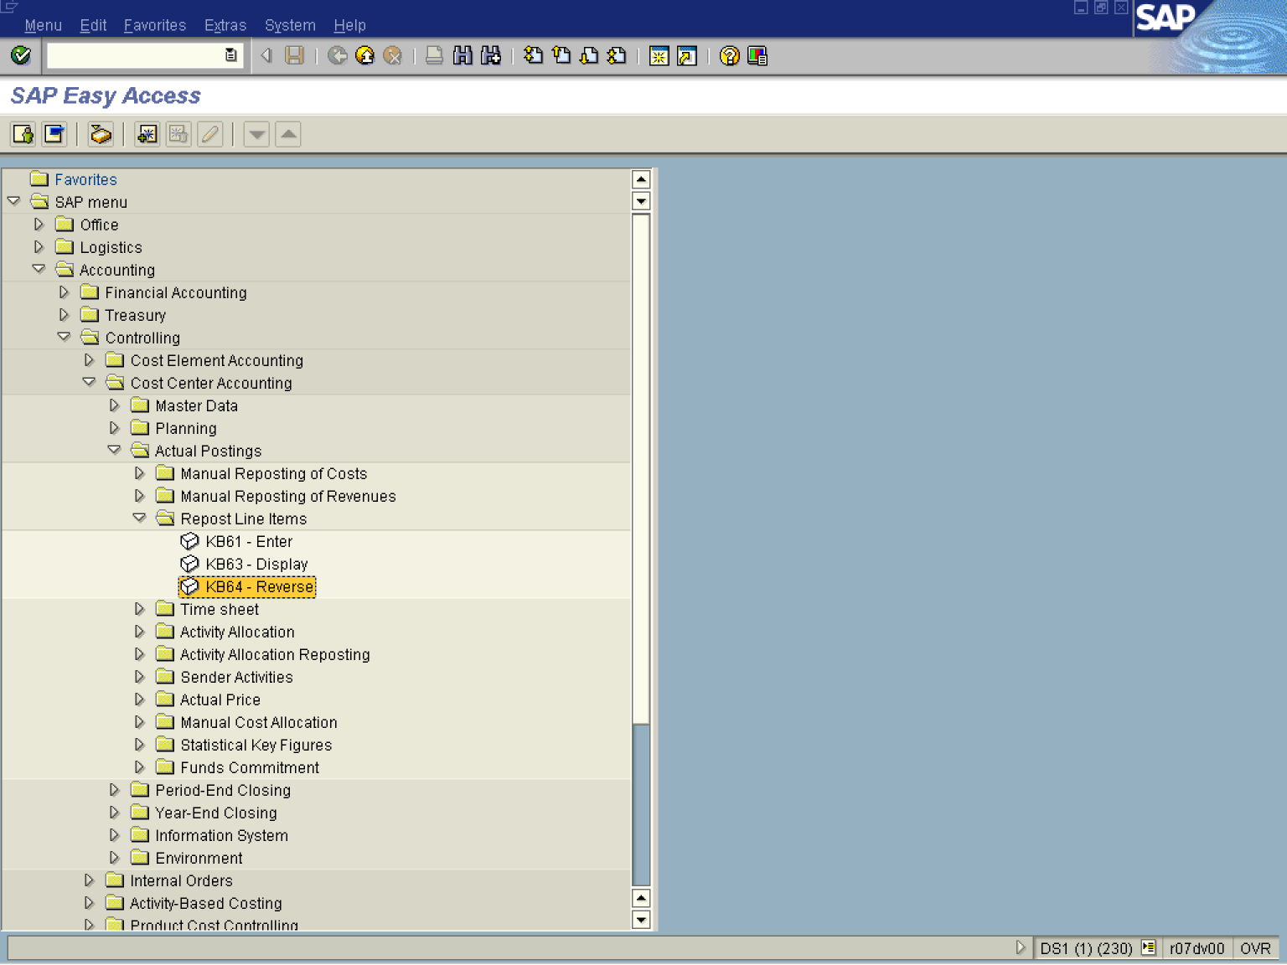

1. Double Click on KB64 – Reverse

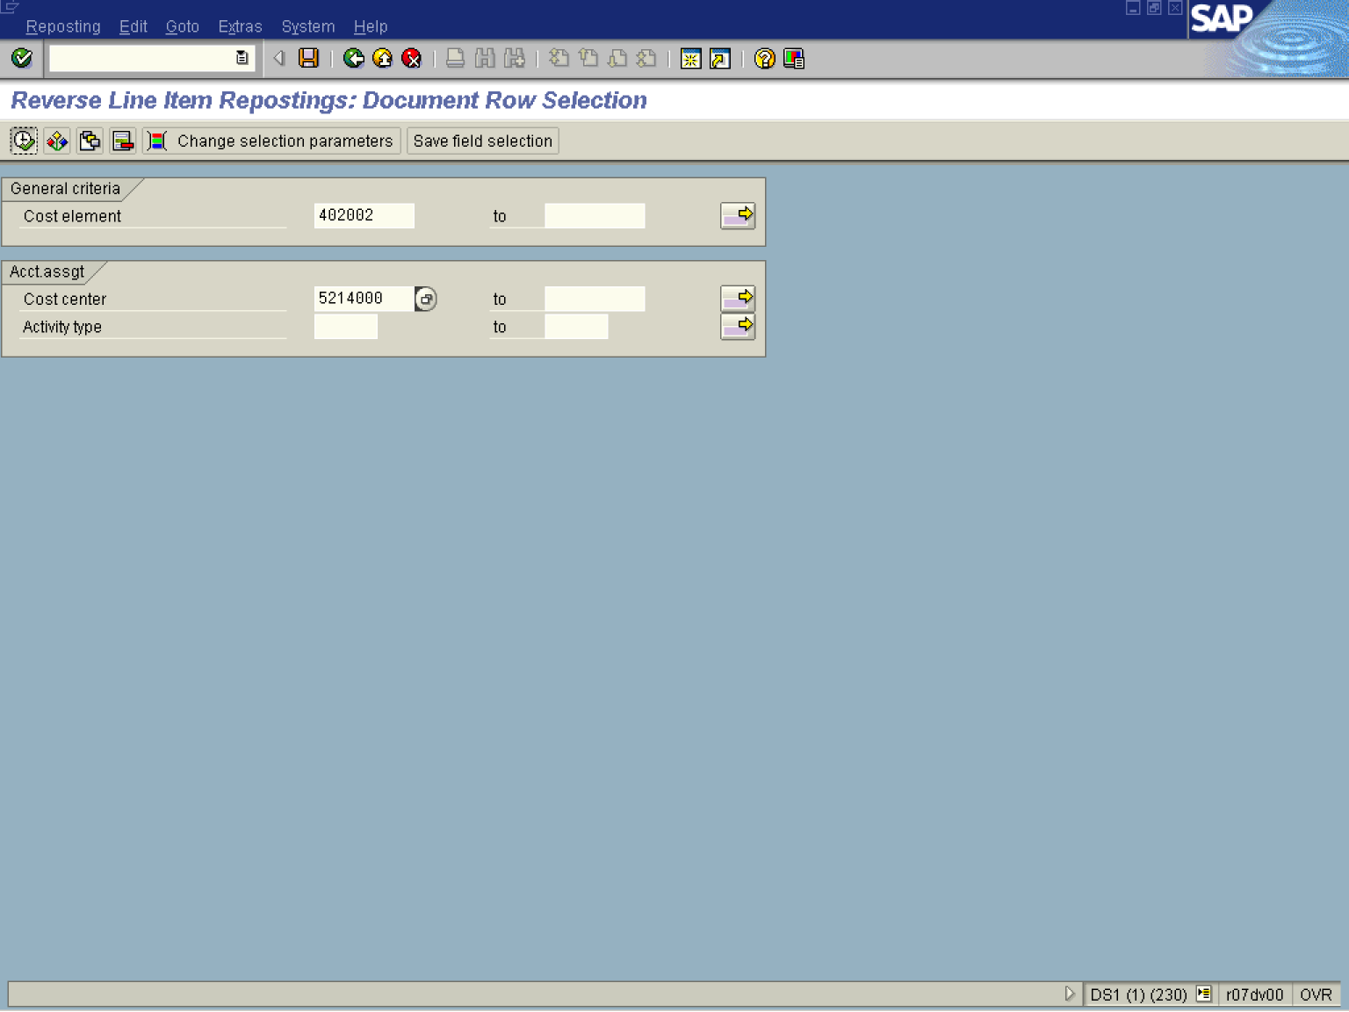

2. Update the following fields:

Field Name | Description | Values
Cost element | Items in a chart of accounts that are relevant to cost, are referred to as cost elements | Example: 402002
Cost center | Code identifying an organizational unit to which costs or assets are assigned | Example: 5214000

3. Click Enter
4. Click Execute

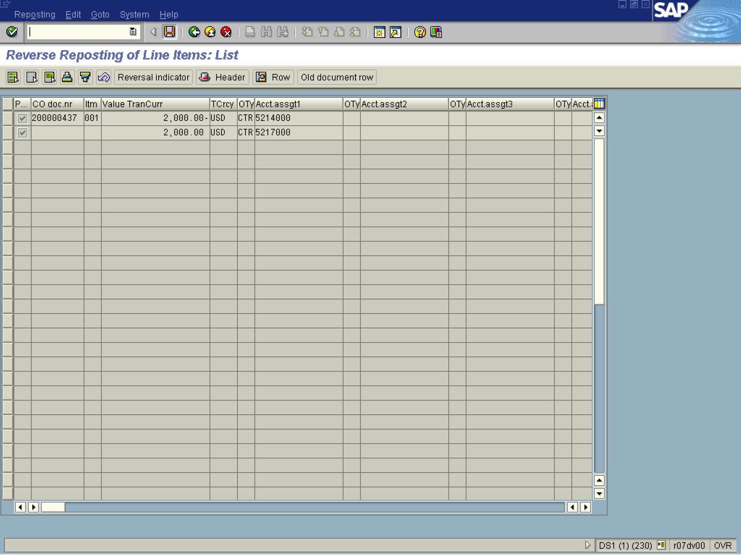

5. Select the relevant item by selecting the button on the left of the record. Once selected, the line turn to dark gray.
6. Click Reversal indicator .
7. Click Save

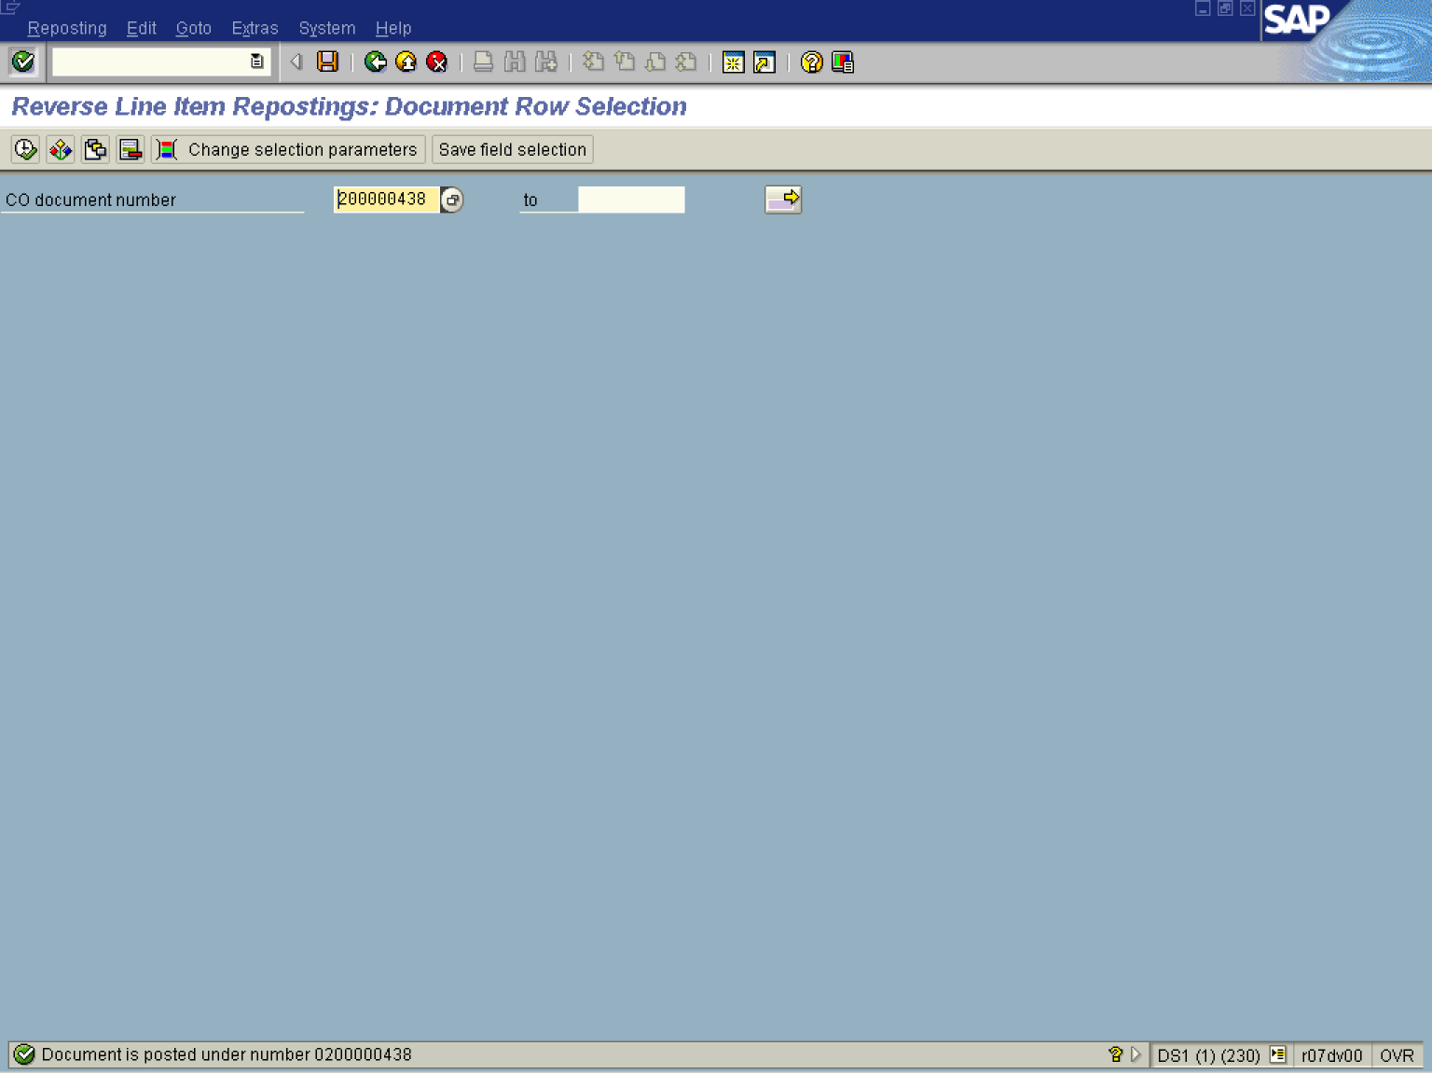

8. The message bar displays “Document posted under number XXXXXXX”

